*Florida International University*

*School of Computing and Information Sciences*

Software Engineering Focus

Feature Document

User Story ID <689 Send New Snack form>

**Name:Bertha M Perez**

**Frank Hernandez**

**Team Member(s): Bertha M Perez**

**Frank Hernandez**

**Project: Snackability 1.0**

**Product Owner(s)**: Dr. Cristina Palacios

**Mentor(s)**:

**Instructor**: Masoud Sadjadi

**User Story Name:** 689 Send New Snack form

### Description:

* As a User I would like to be able to fill a form to suggest new snacks to the admin so the snackability keep updated

### Acceptance Criteria:

1. User want to suggest a new snack to the administrator.

Related Tasks:

**Use Case**

|  |  |
| --- | --- |
| Use Case Name: New Snack Suggestion | |
| Participant Actor: User | |
| Entry Condition:   * User must be log in | |
| Exit Condition: User suggest a new snack to the administrator | |
| **Flow of Events** | |
| **Actor Steps** | **System Steps** |
| 1. User tap Setting  3. User tap Add a Snack | 2. System open Setting page  4. System open form to suggest a snack |
|
| **Use Case Exceptions** | |
| **Actor Steps** |  |
|  |  |

**Use Case Diagram <**you can use draw.io**>**

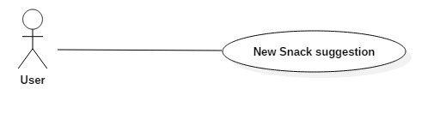

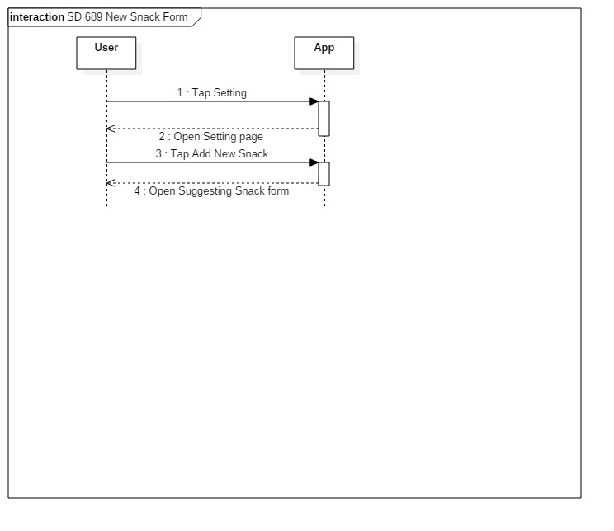

**Sequence Diagram**

**Class Diagram**

**Unit Test**

* Test case ID:
* Description/Summary of Test:
* Pre-condition:
* Expected Results:
* Actual Result:
* Status (Fail/Pass):

**Integration Test**

**Visual User Guide** <like one or two screenshots of the feature. For the hardware project, a photo of device is required>